# **Cross-Cultural Comparison Workshop**

# Pathways to Cross Cultural Understanding Conference

# (October 14, 2023)

Micky Miller

millermi@shcsc.k12.in.us

Corydon Central High School

Corydon, IN 47112

## Title

Changing the World through Music: Unity and Understanding

**1. Reflection**

On Saturday, October 14, I was fortunate to attend the inaugural PCCU Conference at the Korean Cultural Center of Chicago. The focus of this conference was learning about Korean art as a way of advancing cultural awareness. As a teacher in a predominantly white school, increasing my students’ awareness of other cultures and communities around them is of extreme importance, and I found the content of this conference to be of great interest and importance.

I thought more about the topic of music as I worked on coming up with ideas about my lesson plan. Typically I would gravitate toward planning for a World History or World Geography class for a topic such as this, but our standards for these courses in Indiana do not easily accommodate teaching about culture, especially music. I truly believe that music has been a unifying force throughout history, and as such could be used to accent my teaching in either course. However, at my school, we have two 40-minutes periods per week that we can use for intervention or extension/enrichment purposes, and I felt that this would be a great enrichment lesson, especially when we start Korean history.

I, in my spare time, play the flute, and have for over 30 years. One of the pieces I remember learning in high school was entitled *Variations on a Korean Folk Song*. The base melody is *Arirang*, and I have admittedly been obsessed with the tune since first learning it and to this day I often find myself humming it. I love the idea of being able to share it with my students while also allowing them the opportunity to explore the folk music of the United States, while also potentially opening up their eyes – and ears – to other music from around the world.

**2. Explanation of Opportunities**

I am able to teach about East Asia in both classes that I teach. The easiest in which to implement the subject area is in my Honors World History classes, but I am increasingly finding ways to incorporate it into my U.S. Government classes. In World History (and sometimes Geography & History of the World, which we alternate), we talk about different cultural aspects, bringing in ideas as we touch upon a historical topic, and provide opportunities for students to link what we are learning about with what we identify as our own culture. In U.S. Government, we compare and contrast different government types. I will have the opportunity to share my lesson with colleagues within my department at school, as well as with the art teacher, who may be interesting in pairing on this project.

**3. Description**

This lesson plan is designed for use in a 40-minute block in a suburban high school. It is a Social Studies unit, designed according to the standards for Sociology, for the high school student. The lesson will take place over three 40-minute blocks.

**Lesson activities**

| Day 1 | * Play the Spotify playlist *The Sound of Korean Traditional* as students walk into the room and take their seats. After five to ten minutes of listening, ask students their opinions about the music. What connections can they find with American traditional music? What instruments do they hear? * Play a video of the New York Philharmonic performing *Arirang* in Pyongyang. This concert took place in 2008 and was considered a remarkable feat in US-North Korean relations. While this concert was once readily available online, you can only access it now through purchasing a video of the performance or through streaming selections via YouTube. The particular clip I am using is from YouTube. I would ask students to watch the expressions of attendees – what are they thinking? * After viewing the video, students will research the selections performed by the New York Philharmonic during that concert. Why do you think the music chosen was selected? How is music being used as a diplomatic tool? * Have students read “The Most Popular Korean Song of All Time.” Ask them to think about what the most popular song from the United States would be before the next meeting. |
| --- | --- |
| Day 2 | * Students will discuss what song they believe to be the American mirror of *Arirang*. What makes their chosen song ideal? The class will then vote on what song they believe best represents the American spirit as a whole. * Students will break into pairs and examine the Smithsonian’s website on American Folk Music. We will utilize the Analyzing Sound Recordings form from the Library of Congress as each pair listens to two pieces of music of their choice. * Students will create, as a class, a Spotify playlist of songs that they best feel express American history and culture. |
| Day 3 | * Today we will look at modern pop music and how it can be used to teach history. We will focus on   + *We Didn’t Start the Fire* by Billy Joel   + *We Didn’t Start the Fire* *2023* by Fall Out Boy   + *Super* by Seventeen   + *That’s My Fault* by Speed * Play a video of each song and allow students to discuss after each video. What stood out from the video? * Students will discuss how music can be used to teach history. What did the artists intend to accomplish by recording these pieces? |

**4. Standards**

| S.2.1 | Define culture and identify the material and non-material components of culture. |
| --- | --- |
| S.2.2 | Explain the differences between the concepts: culture and society. |
| S.2.5 | Identify culture conflict, cultural similarity, cultural diversity. |

**5. Days and Class Time Required**

* This lesson plan is designed for use in a 40-minute block used for enrichment in a suburban high school. It is a Social Studies unit, designed according to the Indiana standards for Sociology, for any student in the high school setting. The lesson will take place over three 40-minute blocks.

**6. Resources**

“2023 National Recording Registry Additions: John Lennon, Led Zeppelin, Madonna and ‘Super Mario Bros..’” *CBS News*, CBS Interactive, www.cbsnews.com/news/national-recording-registry-2023-john-lennon-led-zeppelin-madonna-super-mario-bros/. Accessed 21 Oct. 2023.

“About This Collection  :  National Jukebox  :  Digital Collections  :  Library of Congress.” *The Library of Congress*, www.loc.gov/collections/national-jukebox/about-this-collection/. Accessed 20 Oct. 2023.

“The Most Popular Korean Song of All Time.” *Go! Go! Hanguk*, 17 Dec. 2019, gogohanguk.com/en/blog/the-most-popular-korean-song-of-all-time/.

“The Music of Korea: A Rough Guide.” *Songlines*, www.songlines.co.uk/the-rough-guide-to-world-music/the-music-of-korea-a-rough-guide. Accessed 22 Oct. 2023.

“Seventeen Takes the World by Storm with K-Pop - Weverse Magazine.” *Weverse Magazine - Everything K-Pop, and More!*, magazine.weverse.io/article/view?lang=en&colca=5&artist=&searchword=&num=706. Accessed 18 Oct. 2023.

Smithsonian Institution. “American Folk Music.” *Smithsonian Institution*, www.si.edu/spotlight/american-folk-music. Accessed 23 Oct. 2023.

Ulaby, Neda. “The Library of Congress Is Preserving These Major Historical Recordings for Posterity.” *NPR*, NPR, 13 Apr. 2022, www.npr.org/2022/04/13/1091585574/the-library-of-congress-adds-25-titles-including-alicia-keys-and-ricky-martin.

“UNESCO - Arirang, Lyrical Folk Song in the Republic of Korea.” *Intangible Cultural Heritage*, ich.unesco.org/en/RL/arirang-lyrical-folk-song-in-the-republic-of-korea-00445. Accessed 18 Oct. 2023.

Zukas, Alex. “Different Drummers: Using Music to Teach History: Perspectives on History: AHA.” *Different Drummers: Using Music to Teach History | Perspectives on History | AHA*, www.historians.org/research-and-publications/perspectives-on-history/september-1996/different-drummers-using-music-to-teach-history. Accessed 18 Oct. 2023.

**7. Other Materials**

* CDs or online playlists of music – traditional, popular, modern. Spotify and the Library of Congress have excellent playlists available. As these are able to be continuously created and modified, a teacher utilizing these would want to research these well enough in advance.

**8. Enrichment**

* If you are lucky enough to be near a larger metropolitan area, you may have luck in attending local performances of many different musical styles. While this lesson particularly looks at comparing Korean and American music, it can be changed to accommodate other cultural styles that may go hand in hand with other performances.
* Likewise, look for local festivals that could tie in to what is being taught in the lesson!
* Check out the programs offered by Pathways to Cross Cultural Understanding, and sign up for a workshop! You can find out more at <https://www.pcrosscultural.com/>.

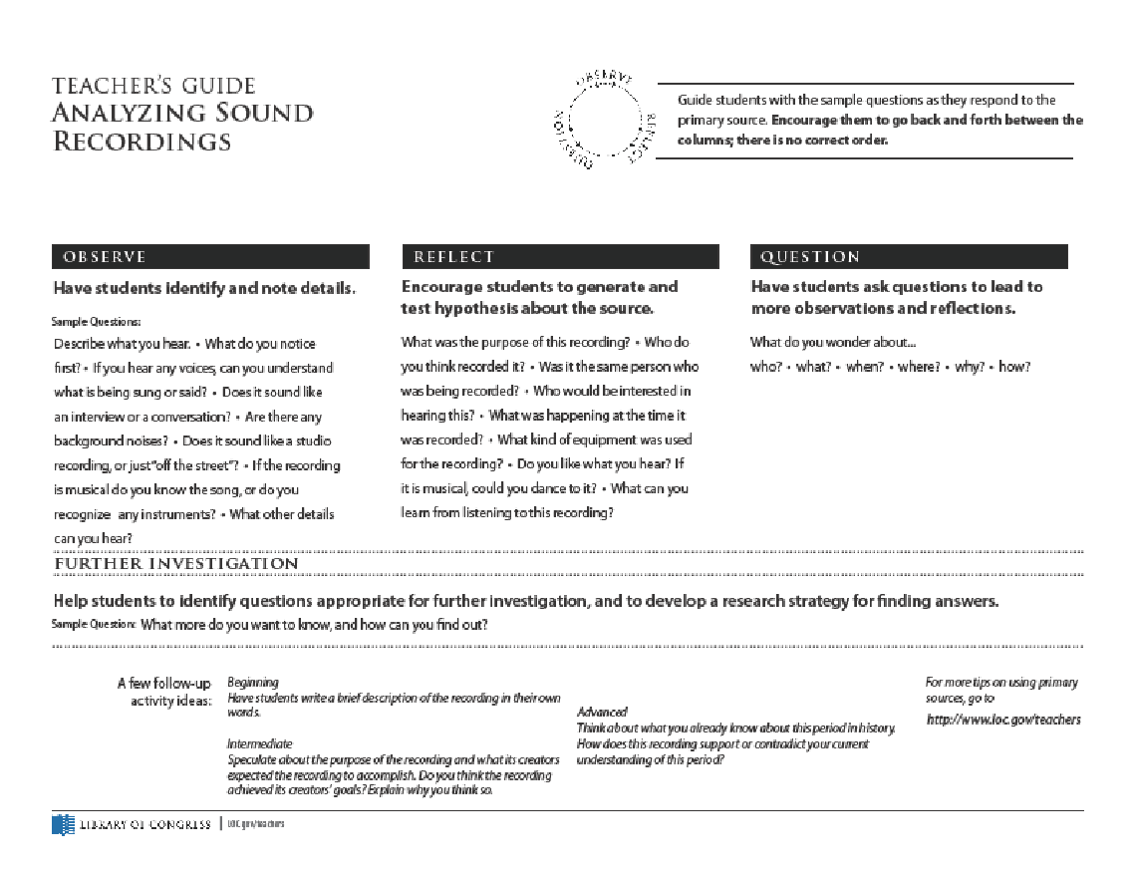

This page is from the Library of Congress, and is utilized in the lesson. A full sized copy can be obtained at <https://www.loc.gov/static/programs/teachers/getting-started-with-primary-sources/documents/Analyzing_Sound_Recordings.pdf>